BỘ GIÁO DỤC VÀ ĐÀO TẠO TRƯỜNG ĐẠI HỌC VĂN LANG
KHOA KỸ THUẬT CƠ ĐIỆN VÀ MÁY TÍNH



CAPSTONE PROJECT – GROUP 15
Design and Development of a Simulation-Based Game
Application for Fire Prevention and Firefighting Training
Major: Software Engineering
Document:

SOFTWARE ARCHITECTURE DESIGN

Version: 1.1 | Date updated: April 29th, 2026
Group Student:

BÙI LÊ ĐỨC HUY* | 2274801030183
BÙI LÊ ĐỨC HIẾU | 2274801030046
LÊ TUẤN ANH | 2274801030228

Mentor: Ths. Lã Hoàng Quý

Hồ Chí Minh City – January 20th, 2026

REVISION HISTORY
Project Information Overview
Project Title | Design and Development of a Simulation-Based Game Application for Fire Prevention and Firefighting Training
Product Name | Ignis Guard
Project Mentor | Ths. Lã Hoàng Quý
Partner Organization | No external partner organization
Team members | Bùi Lê Đức Huy* | 2274801030183
 | Bùi Lê Đức Hiếu | 2274801030046
 | Lê Tuấn Anh | 2274801030228

Document Information
Document Title | SOFTWARE ARCHITECTURE DESIGN
Author(s), Role(s) | Bùi Lê Đức Huy | Team Leader, Unity Programmer, Game Designer, 3D Artist
 | Bùi Lê Đức Hiếu | Unity Programmer, Game Designer, UI/UX Designer, Writer/Content
 | Lê Tuấn Anh | Writer/Content, QA, Game Designer
Changelog | 20/1/2026 – v1.0 | Initial release of SAD v1.0. Architecture overview, component design, data design, deployment, patterns, and traceability matrix based on SRS v1.0 and PP v1.2.
 | 29/4/2026 – v1.1 | Synchronized with SRS v1.3, PP v1.3, and SPQP v1.3. Updated: (1) References R2/R3/R4 to current versions. (2) Incident State expanded from 4 to 7 variables (added electric-hazard status, victim count, victim location hints) in Sections 5.4 and 6.2. (3) Bot command set updated to BotCommandAgent: Follow, Extinguish, Rescue, Breach/PathClearing, Move-to-point, Wait. (4) Added FR-02, FR-09, FR-12, FR-14, FR-15, FR-16, FR-19, FR-20 to Table 9.1. (5) Added Fire Simulation System and Seed System components to Table 9.3. (6) Updated Mission System to Flat Objective Architecture (parallel tracking, no hard prerequisite gates). (7) Added ToolWheel equipment set description to Section 5.6. (8) Added Jira, Blender, Photoshop to Table 2.3 technology overview. (9) Fixed FR-01 trace from Game Flow Controller to Mission System.

TABLE OF CONTENTS
REVISION HISTORY 2
TABLE OF CONTENTS 5
LIST OF FIGURES 9
LIST OF TABLES 10
Chapter 1. Introduction 12
1.1 Purpose 12
1.2 Scope 12
1.3 Relationship to SRS and Other Project Documents 12
1.4 References 13
1.5 Intended Audience 13
1.6 Document Organization 14
Chapter 2. System Overview 15
2.1 System Purpose 15
2.2 Overall System Context 15
2.3 Core Gameplay / Operational Flow 15
2.4 High-Level System Capabilities 16
2.5 Shared Architecture for Two Scenarios 17
2.6 Technology Overview 17
Chapter 3. Architectural Drivers 19
3.1 Functional Requirements Driving the Architecture 19
3.2 Non-Functional Requirements Driving the Architecture 24
3.3 Design Constraints 25
3.4 Assumptions and Dependencies 25
3.5 Key Architectural Goals 26
Chapter 4. Architectural Structure 27
4.1 Selected Architectural Style 27
4.2 Static View 27
4.2.1 Layer / Module Structure 27
4.2.2 Package / Component Overview 28
4.2.3 Responsibility Allocation 28
4.3 Dynamic View 29
4.3.1 End-to-End Runtime Flow 29
4.3.2 Main Interaction Sequence 30
4.3.3 State Transitions 31
4.4 Physical View 31
4.4.1 Runtime Environment 31
4.4.2 Build / Execution Environment 31
4.5 Architecture Rationale 32
Chapter 5. Component Design 33
5.1 Main Menu and Scenario Selection 33
5.2 Game Flow Controller 34
5.3 Call Phase Module 35
5.4 Incident State Mapping Engine 35
5.5 Scenario Configuration and Scene Loader 36
5.6 On-site Gameplay Module 37
5.7 Mission and Objective System 39
5.8 Teammate Command / Bot Module 40
5.9 Scoring and Evaluation Module 40
5.10 Debrief Module 41
5.11 UI / HUD Module 42
5.12 Local Logging / Telemetry Module 43
Chapter 6. Data Design 45
6.1 Data Design Overview 45
6.2 Core Data Entities 45
6.3 Question and Answer Data Model 46
6.4 Incident State and Scenario Configuration Data 47
6.5 Mission and Objective Data Model 47
6.6 Scoring, Debrief, and Telemetry Data 48
6.7 Data Storage and Configuration Format 48
6.8 Data Validation and Integrity Rules 48
Chapter 7. Deployment Design 50
7.1 Target Platform and Environment 50
7.2 Software Deployment Structure 50
7.3 Build and Packaging Strategy 50
7.4 Runtime Dependencies 50
7.5 Configuration and Versioning Considerations 51
7.6 Operational Limitations 51
Chapter 8. Design Patterns and Frameworks 52
8.1 Architectural Patterns Used 52
8.2 Design Patterns Used 52
8.3 Frameworks / Libraries / Engine Support 53
8.4 Rationale for Pattern and Technology Selection 53
Chapter 9. Traceability Matrix 54
9.1 Functional Requirement to Architecture Mapping 54
9.2 Non-Functional Requirement to Architecture Mapping 55
9.3 Component-to-Requirement Traceability Summary 56

LIST OF FIGURES
Figure 2.1 Shared gameplay loop of Ignis Guard across the two approved scenarios. 15
Figure 4.1 Static architecture view showing layers and major components. 25
Figure 4.2 Simplified dynamic flow from call interaction to debrief generation 27
Figure 4.3 Simplified state machine for the major user-visible runtime states 28
Figure 4.4 Physical / deployment view for local build creation and runtime execution 28
Figure 6.1 Simplified data relationships across the core architecture 42

LIST OF TABLES
Table 1.1 References and Their Use in This SAD 13
Table 2.1 Overview of Capability Areas 15
Table 2.2 Scenario Characteristics and Reuse Strategy 16
Table 2.3 Technology Overview and Roles 17
Table 3.1 Functional Requirements and Their Architectural Impact 18
Table 3.2 Non-Functional Requirements and Their Architectural Implications 21
Table 3.3 Key Architectural Goals and Their Rationale 23
Table 4.1 Package / Component Overview 25
Table 4.2 Responsibility Allocation of Key Architectural Elements 25
Table 4.3 Physical Environment Overview 29
Table 5.1 Main Menu and Scenario Selection Module Description 30
Table 5.2 Game Flow Controller Module Description 31
Table 5.3 Call Phase Module Description 32
Table 5.4 Incident State Mapping Engine Module Description 32
Table 5.5 Scenario Configuration and Scene Loader Module Description 33
Table 5.6 On-Site Gameplay Module Description 34
Table 5.7 Mission and Objective System Module Description 36
Table 5.8 Teammate Command / Bot Module Description 37
Table 5.9 Scoring and Evaluation Module Description 37
Table 5.10 Debrief Module Description 38
Table 5.11 UI / HUD Module Description 39
Table 5.12 Local Logging / Telemetry Module Description 40
Table 6.1 Core Data Entities and Their Purposes 42
Table 6.2 Question Data Fields and Their Design Roles 43
Table 6.3 Runtime Configuration Structures Overview 44
Table 6.4 Mission Objective Fields and Meanings 44
Table 6.5 Result and Reporting Data Structures 45
Table 7.1 Software Deployment Structure Overview 47
Table 7.2 Runtime Dependencies and Deployment Implications 47
Table 8.1 Architectural Patterns Used in Ignis Guard 49
Table 8.2 Design Patterns Used and Their Rationale 49
Table 8.3 Frameworks / Libraries / Engine Support and Their Roles 50
Table 9.1 Functional Requirement to Architecture Mapping 51
Table 9.2 Non-Functional Requirement to Architecture Mapping 52
Table 9.3 Component-to-Requirement Coverage Matrix 53

Introduction

Purpose
This Software Architecture Design (SAD) document defines the high-level software architecture of Ignis Guard, a simulation-based serious game for fire prevention and firefighting training developed on the Unity platform for PC Windows. The document describes the architectural style, major components, data structures, runtime views, deployment approach, and design rationale that will guide implementation, integration, testing, and future extension.
Although the document title is Software Architecture Design (SAD), it is intentionally organized according to the Software Design Specification (SDS) structure defined in Chapter 4 of the Capstone Project Guidebook. This alignment preserves consistency with the faculty framework while keeping the focus on architecture-level decisions for the Ignis Guard project.

Scope
The scope of this SAD covers the architecture of the playable capstone release of Ignis Guard. The product is a single-player, first-person training game that includes two approved scenarios — Urban High-rise and Suburban House — implemented on top of one shared architecture. The shared gameplay loop is: Main Menu / Scenario Selection → Call Phase → Incident State generation → Loadout Briefing → On-site Mission → Result/Debrief.
This document focuses on architecture-level decisions rather than code-level class design for every script. It therefore emphasizes module boundaries, data flow, architectural views, quality tactics, and traceability to the Software Requirements Specification.

Relationship to SRS and Other Project Documents
The SAD acts as the bridge between requirements and implementation. The SRS defines what the system must do; the Project Plan defines how the work is scheduled; the SPQP defines how quality is managed; and the Project Charter provides the project baseline. This SAD explains how the selected architecture satisfies the critical requirements and how the architecture supports the current two-scenario scope without redesigning the core engine for each scenario.

References
Table 1.1 References and Their Use in This SAD
ID | Reference | Use in This SAD
[R1] | CAPSTONE PROJECT GUIDEBOOK (Chapter 4 SDS framework; Appendix A.3 sample SDS). | Primary academic structure for this document.
[R2] | Software Requirements Specification (SRS) — Ignis Guard, v1.3. | Source of functional, non-functional, and software requirement identifiers.
[R3] | Project Plan — Ignis Guard, v1.3. | Source of schedule, architecture decisions, tool stack, and implementation priorities.
[R4] | Software Process and Quality Plan (SPQP) — Ignis Guard, v1.3. | Source of quality goals, verification approach, and process constraints.
[R5] | Project Charter — Ignis Guard, v1.0. | Source of objectives, scope baseline, and capstone deliverables.

Intended Audience
- Development team members responsible for Unity programming, UI/HUD implementation, content integration, and QA support.
- Project mentor and defense reviewers who need to understand the selected architecture and its rationale.
- Testers and document reviewers who need a stable reference for component responsibilities and requirement coverage.

Document Organization
The document follows the Guidebook SDS structure. Chapters 2 through 8 describe the system overview, architecture drivers, architecture views, components, data, deployment, and patterns. Chapter 9 closes the main body with traceability matrices that connect requirements from the SRS to concrete architectural elements. Supporting terms, abbreviations, diagram notes, and UI architecture notes are included in the appendices.

System Overview

System Purpose
Ignis Guard is designed as a serious game that allows trainees to practice emergency information gathering, tactical assessment, equipment preparation, SOP-oriented mission execution, and reflective learning through debriefing. The system is intended to be repeatable, safe, and educationally coherent: the player must see a clear cause-and-effect relationship between what is learned during the emergency call and what happens later at the incident scene.

Overall System Context
The software runs locally on a Windows PC. The main external actor is the Player. The player uses keyboard and mouse input to navigate menus, ask emergency-call questions, move through the 3D environment, interact with tools, command a bot teammate, and review the result/debrief screen. The system also reads local configuration assets, scenario data, and optional local settings, and it writes playtest telemetry to local storage for tuning and review.

Core Gameplay / Operational Flow
- The player launches the game and reaches the Main Menu, where Tutorial, Settings, and Scenario Selection are available.
- The player selects a scenario and enters the Call Phase, where information is collected through a limited set of emergency-call questions.
- The Incident State engine transforms the collected answers into deterministic scene parameters such as smoke density, fire intensity, spread rate, hazard presence, and victim-related hints.
- The selected scenario is loaded and configured using the calculated parameters, then the player performs on-site objectives with HUD support, firefighting tools, and simple teammate commands.
- When the mission ends, the system computes score, penalties, grade lock status, and a cause-and-effect debrief that explains how earlier decisions influenced later mission conditions.

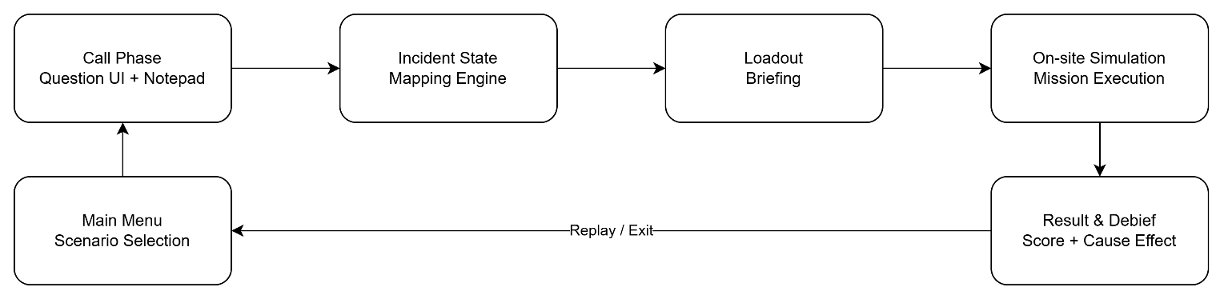
Figure 2.1 Shared gameplay loop of Ignis Guard across the two approved scenarios.

High-Level System Capabilities
Table 2.1 Overview of Capability Areas
Capability Area | Summary
Pre-incident learning loop | Call Phase questioning, notepad updates, Incident State generation, and loadout summary.
Scenario execution | Scenario loading, hazard setup, objective tracking, movement, interaction, and tool use in a first-person 3D environment.
Tactical coordination | Teammate commands via BotCommandAgent: Follow, Extinguish, Rescue, Breach/PathClearing, Move-to-point, and Wait, within the defined scope.
Evaluation and reflection | Safety penalties, score calculation, grade lock, rank output, and debrief timeline for reflective learning.
Playtest support | Local telemetry output, stable build behavior, and data-driven configuration that enables tuning across scenarios.

Shared Architecture for Two Scenarios
The final capstone scope includes two playable scenarios: Urban High-rise and Suburban House. Both scenarios share the same core architecture, meaning that the UI flow, call/question logic, Incident State mapping process, scoring engine, bot command flow, and debrief pipeline remain common. Scenario-specific differences are represented mainly through data, scene content, hazard configuration, mission structure, and localized rule mappings rather than through separate codebases.
Table 2.2 Scenario Characteristics and Reuse Strategy
Scenario | Architecture-Relevant Characteristics | Reuse Strategy
Urban High-rise | Dense vertical interior spaces, stronger navigation pressure, smoke management, and room-by-room objective progression. | Common systems reused; scenario config adjusts mission structure, hazard placement, and victim hints.
Suburban House | Smaller layout with different entry flow, hazard spread pattern, and victim positioning logic. | Common systems reused; scenario config changes environment data, objective chain, and hazard emphasis.

Technology Overview
Table 2.3 Technology Overview and Roles
Category | Technology | Role
Engine | Unity 6.0 LTS (or newer approved LTS build) | Primary runtime and editor environment.
Rendering | Universal Render Pipeline (URP) | Balanced real-time visual quality and target performance.
Programming language | C# | Gameplay logic, UI behavior, scoring, and state orchestration.
Input | Unity Input System | Keyboard and mouse input abstraction.
AI navigation | Unity NavMesh | Basic pathfinding and movement for teammate bots.
Version control | Git / GitHub | Source management and collaboration.
Project management | Jira | Sprint planning, task tracking, and issue management.
3D asset creation | Blender | 3D modeling and asset export for Unity.
2D asset and UI art | Photoshop | UI textures, sprites, and 2D art assets.

Architectural Drivers

Functional Requirements Driving the Architecture
The architecture is directly driven by the functional requirements identified in the SRS. The most influential requirements are summarized below.
Table 3.1 Functional Requirements and Their Architectural Impact
Requirement(s) | Requirement Summary | Architectural Impact
FR-01 | The system shall simulate hazard and rescue events including smoke, fire, gas-related risk, and victim incidents, and shall allow the player to respond within the defined scope of each scenario. | Requires On-site Gameplay Module and Mission System to handle hazard/rescue events; Fire Simulation System (FireSimulationManager) must be a distinct runtime component consumed by both gameplay and scoring.
FR-02 | The system shall provide a Tutorial/Training mode for players to learn basic actions before entering a mission. | Requires a dedicated Tutorial scene that reuses the On-site Gameplay Module's interaction and movement systems with a checklist overlay managed by the UI/HUD layer.
FR-03 | The system shall allow selection of at least 2 scenarios: Urban High-rise and Suburban House. | Requires a reusable Scenario Configuration and Scene Loader approach rather than scenario-specific hard-coded flows; both scenarios share one common architecture.
FR-04 | The system shall provide the Call Phase as a list of emergency-call questions with a time limit or question limit. | Requires a dedicated Call Phase Module with bounded question selection, timer/turn logic, and a question bank data structure.
FR-05 | The system shall automatically update the notepad from gathered information and allow the player to review the summary. | Requires the Call Phase Module to continuously publish updates to the UI/HUD notepad view; summary panel must reflect provisional Incident State in real time.
FR-06 | The system shall infer an Incident State that includes at least smoke density, fire intensity, spread rate, gas-hazard status, electric-hazard status, victim count, and victim location hints. | Requires the Incident State Mapping Engine to evaluate 7 distinct variables deterministically from CallSession data; output must be a structured IncidentState object consumed by downstream components.
FR-07 | The system shall generate a loadout summary before the On-site Phase and state the main reasons for each selection. | Requires a loadout recommendation layer within the Incident State Engine that maps IncidentState to equipment/supply list and exposes the recommendation basis to the UI.
FR-08 | The system shall allow entry into the On-site Phase with the HUD and mission tree initialized correctly. | Requires a clean handoff between Game Flow Controller, Scenario Loader, Mission System, and UI/HUD; all four must be ready before gameplay begins.
FR-09 | The system shall support movement, interaction, and tool use in FPS gameplay; the full ToolWheel equipment set shall be implemented. | Requires the On-site Gameplay Module to implement all ToolWheel items (ThermalCamera, OxygenMask, VictimStabilizationKit, RescueCushionPlaceable, StandardLadderPlaceable, RopeLadderPlaceable, PortableWorkLightPlaceable, fire extinguisher, MeshShatter/Breakable); tool effects must produce interaction events consumed by Mission System and Scoring.
FR-10 | The system shall generate and update a mission tree consisting of main objectives and side objectives according to the rule set. | Requires the Mission and Objective System to track objectives in parallel using a Flat Objective Architecture (event-driven, no hard prerequisite gates); main vs. side distinction is preserved for scoring.
FR-11 | The system shall support at minimum the bot commands: Follow, Extinguish, Rescue, Breach/PathClearing, Move-to-point, and Wait. | Requires the Teammate Command / Bot Module (BotCommandAgent) to translate each command into a distinct AI behavior state; NavMesh-based pathfinding and per-command fallback handling are mandatory.
FR-12 | The system shall simulate hazards and rescue flow sufficiently for the player to handle gas/fire/smoke risks and victims within the scenario scope. | Requires the Fire Simulation System (FireSimulationManager / FireSpreadBatchRunner) to manage hazard spread; gas-hazard and electric-hazard events must derive from IncidentState; victim rescue flow connects On-site Gameplay Module, Mission System, and Bot Module.
FR-13 | The system shall always display the Debrief after a mission, including score breakdown, cause-and-effect timeline, and rank C→S. | Requires persistent event capture across the full session; Scoring Module and Debrief Module must produce a complete DebriefRecord even for fail or timeout outcomes.
FR-14 | The system shall allow Replay Scenario or Exit to Menu after the Debrief. | Requires the Game Flow Controller to support a Replay path (reset session → return to Call Phase) and an Exit path (release resources → Main Menu) from the Debrief state.
FR-15 | The system shall allow the player to pause and resume a mission without losing local mission state, objective state, or required HUD context. | Requires the Game Flow Controller to own a Pause state that freezes gameplay updates; Mission System and HUD must serialize and restore state cleanly across pause/resume transitions.
FR-16 | The system shall allow adjustment of basic Settings and save them locally if the save feature is enabled. | Requires a Settings screen within the UI/HUD layer backed by a local persistence mechanism; settings must be restored on next launch without affecting core gameplay logic.
FR-17 | The system shall persist minimum local telemetry for playtesting/tuning by build version, stored in a location accessible to Dev/QA. | Requires the Local Logging / Telemetry Module to write structured output (scenario, build version, mission time, objective completion, penalties, final rank) with non-blocking failure behavior.
FR-18 | The system shall apply safety penalties and a grade lock when the player commits serious safety violations. | Requires the Scoring Module to monitor violation events during runtime and apply grade-lock logic before computing the final rank; penalty events must be captured in the ScoreRecord and surfaced in the Debrief.
FR-19 | The system shall implement a cluster-based fire simulation (FireSimulationManager / FireSpreadBatchRunner) with scorch decals, smoke accumulation/detection, and smoke ventilation. | Requires a dedicated Fire Simulation System component with FireSimulationManager, FireSpreadBatchRunner, FireScorchDecalController, SmokeHazard, SmokeAlarmDetector, and SmokeVentVfxController; this system must integrate with On-site Gameplay (suppression actions) and Mission System (hazard-state events).
FR-20 | The system shall implement a deterministic seed system (IncidentSeedUtility / IncidentWorldSetupPayload) so that the same Call Phase answers always reproduce an identical world state. | Requires the Seed System to generate a numeric seed from Call Phase answers + risk assessment + incident report data; IncidentWorldSetupPayload is consumed by the Scenario Loader to configure door lock states (DoorLockRandomizerStartupTask), victim positions, hazard placements, and fire cluster starting positions deterministically.

Non-Functional Requirements Driving the Architecture
Table 3.2 Non-Functional Requirements and Their Architectural Implications
Driver | Implication | Tactic
NFR-01 Performance | Maintain acceptable frame rate on target demo hardware. | Use bounded scene complexity, modular scene activation, and lightweight rule evaluation.
NFR-03 Stability | Complete multiple core loops without crash blocker. | Use explicit state transitions, defensive scene loading, and isolated failure handling for optional subsystems.
NFR-05 Maintainability | Common content changes should not require rewriting core gameplay logic. | Favor data-driven scenario definitions and configurable thresholds / tables.
NFR-06 Learnability | New players should understand the basic loop quickly. | Keep UI modules readable and preserve a coherent state sequence across screens.
NFR-04 Bot Robustness | Bots should recover or fail gracefully on navigation issues. | Scope the command set and add fallback or cancellation behavior.

Design Constraints
- The target platform is PC Windows only; no mobile, VR, or multiplayer deployment is included in the approved scope.
- The product is a single-player serious game implemented by a 3-member student team in a 20-week capstone timeline.
- The architecture must remain practical for Unity development and should avoid external backend services, cloud dependencies, or open-ended NLP systems.
- The final product must support two approved scenarios while preserving one shared architecture and one coherent training loop.
- The system must support local execution and offline demonstration in a defense context.

Assumptions and Dependencies
- Scenario behavior will be represented through data assets (such as ScriptableObjects and configuration tables) rather than by duplicating full gameplay logic per scenario.
- The Unity packages identified in the Project Plan, including URP, Input System, and NavMesh, remain available and stable during implementation.
- Asset packs and prototype content are sufficient for demonstrating architecture and gameplay flow without requiring full production-level realism.
- Local telemetry storage is sufficient for capstone evaluation; no server-side analytics are required.

Key Architectural Goals
Table 3.3 Key Architectural Goals and Their Rationale
Goal | Why It Matters
Modularity | Enable independent development and debugging of UI, call logic, scene loading, mission logic, scoring, and telemetry.
Determinism | Ensure that equivalent call inputs produce equivalent Incident State and scenario effects to support educational consistency.
Scenario scalability | Allow scenario growth through data/configuration rather than through rewriting the game loop.
Traceability | Provide clear mapping from requirements to components and from components to verification effort.
Operational simplicity | Keep the runtime architecture feasible for a small student team and stable during local demo execution.

Architectural Structure

Selected Architectural Style
Ignis Guard uses a Modular State-Based Architecture with a Data-Driven Scenario Configuration approach. A finite state machine (FSM) governs the main runtime states of the product, while discrete modules implement call interaction, Incident State mapping, mission flow, scoring, UI, and telemetry. Scenario-specific differences are expressed through configuration data and scene composition, which allows the architecture to support more than one scenario without introducing duplicate end-to-end logic.
At a practical level, the architecture mixes three complementary ideas: (1) explicit application states for predictable flow, (2) modular domain components that can be tested in isolation, and (3) a session context / event-broker style handoff that transfers data from the Call Phase into On-site mission configuration and later into debrief generation.

Static View

Layer / Module Structure
The static architecture is organized into four logical layers: Presentation, Application Control, Gameplay Domain, and Data / Infrastructure. This is a logical separation rather than a strict enterprise layered deployment. It is intended to keep responsibilities understandable for a Unity-based serious game project.
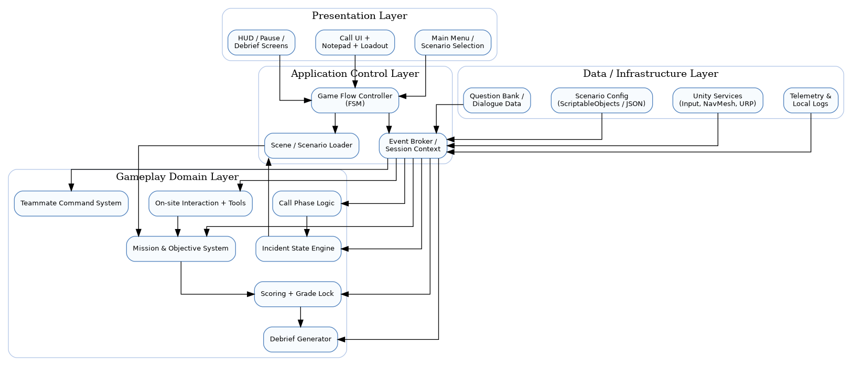
Figure 4.1 Static architecture view showing layers and major components.

Package / Component Overview
Table 4.1 Package / Component Overview
Layer | Contained Elements
Presentation | Main Menu, Scenario Selection, Call UI, Notepad, Loadout Screen, HUD, Pause Menu, Debrief Screen
Application Control | Game Flow Controller, Session Context, Scene/Scenario Loader, Event Broker
Gameplay Domain | Call Logic, Incident State Engine, Mission System, On-site Interaction, Tool System, Bot Command System, Scoring, Debrief Generator
Data / Infrastructure | Scenario Config, Question Bank, Local Settings, Telemetry Logs, Unity services such as Input and NavMesh

Responsibility Allocation
Table 4.2 Responsibility Allocation of Key Architectural Elements
Element | Primary Responsibility
Game Flow Controller | Owns allowed state transitions and guards invalid navigation between major screens and runtime phases.
Session Context / Event Broker | Stores scenario choice, call results, Incident State, and mission result data across phase transitions.
Domain modules | Perform rules, simulation-oriented logic, state updates, scoring, and debrief generation.
Presentation modules | Render information, receive player input, and expose the current state without owning the core mission logic.

Dynamic View

End-to-End Runtime Flow
The dynamic behavior of the system is centered on a controlled handoff pipeline. The player interacts with the Call Phase UI; the system stores answers in a call-session object; the Incident State engine converts those answers into deterministic variables; the scenario loader configures the selected scene; on-site systems process mission events; and the scoring / debrief pipeline summarizes the result.

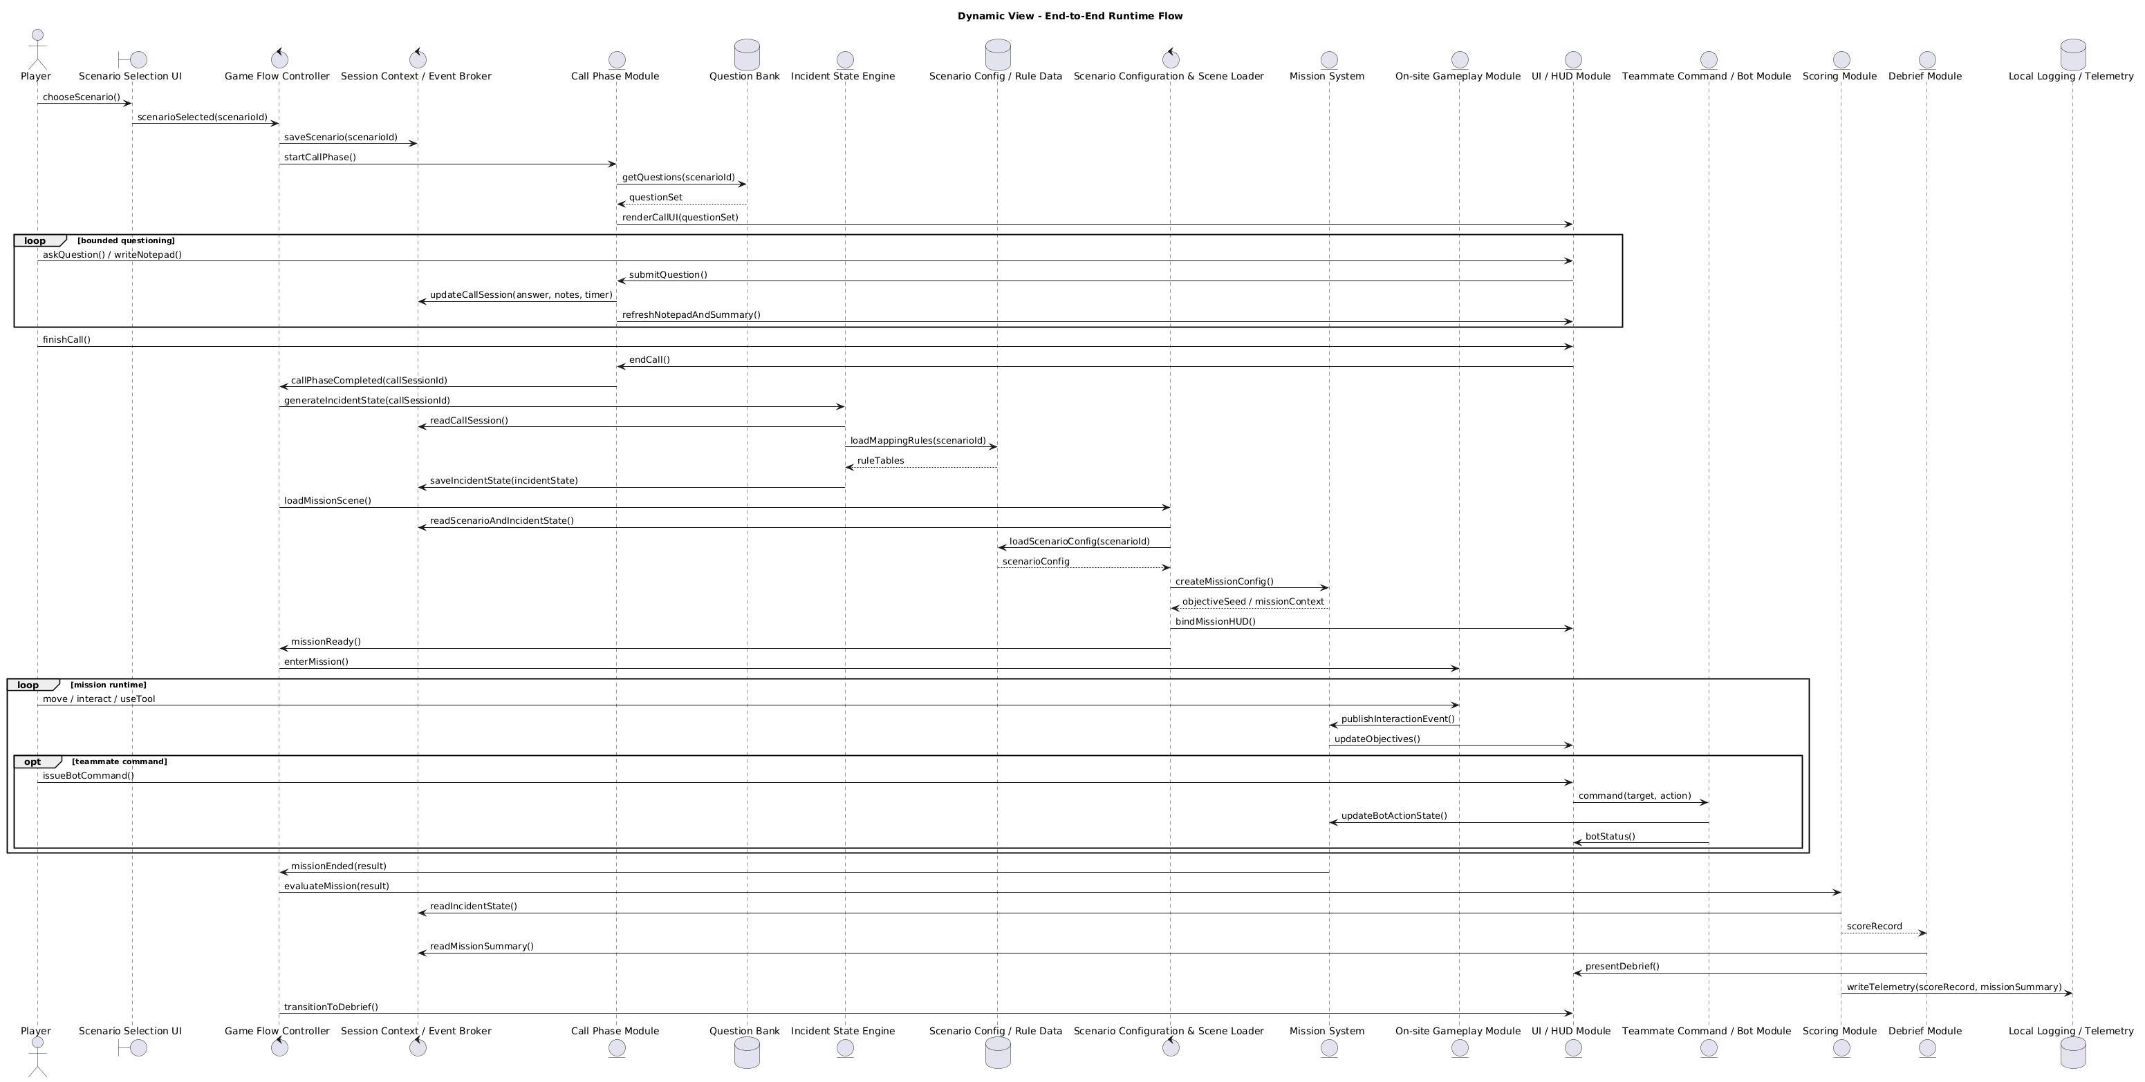
Figure 4.2 Simplified dynamic flow from call interaction to debrief generation

Main Interaction Sequence
- The player selects a scenario and initiates the Call Phase.
- The Call Phase module captures question selections, caller responses, timer/turn results, and notepad updates.
- The Incident State engine maps the final call-session data into normalized parameters required for mission configuration.
- The scenario loader instantiates the mission scene and applies the parameterized configuration, including hazard state and mission context.
- During runtime, the mission system, tool system, bot commands, and HUD exchange events through the active mission state.
- At mission end, the scoring module computes mission outcome, penalties, grade lock, and final rank before the debrief module produces the final feedback presentation.

State Transitions
State transitions are explicit and bounded. Invalid transitions should be blocked rather than inferred. For example, the system should not enter the On-site Mission state before a valid scenario has been selected and the minimum Call Phase result has been produced.
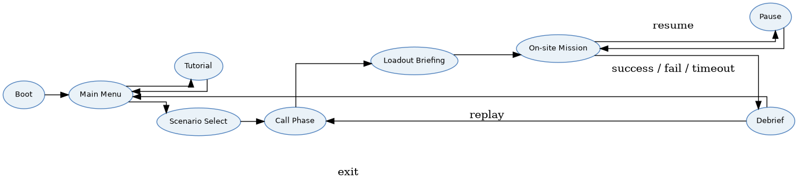
Figure 4.3 Simplified state machine for the major user-visible runtime states

Physical View

Runtime Environment
The physical deployment is intentionally simple. The final build is a locally executed Windows application. Assets, scenario data, and configuration files are packaged with the build. Local files are also used for optional settings persistence and telemetry output. There is no mandatory remote infrastructure, backend API, or online service in the approved capstone scope.

Build / Execution Environment
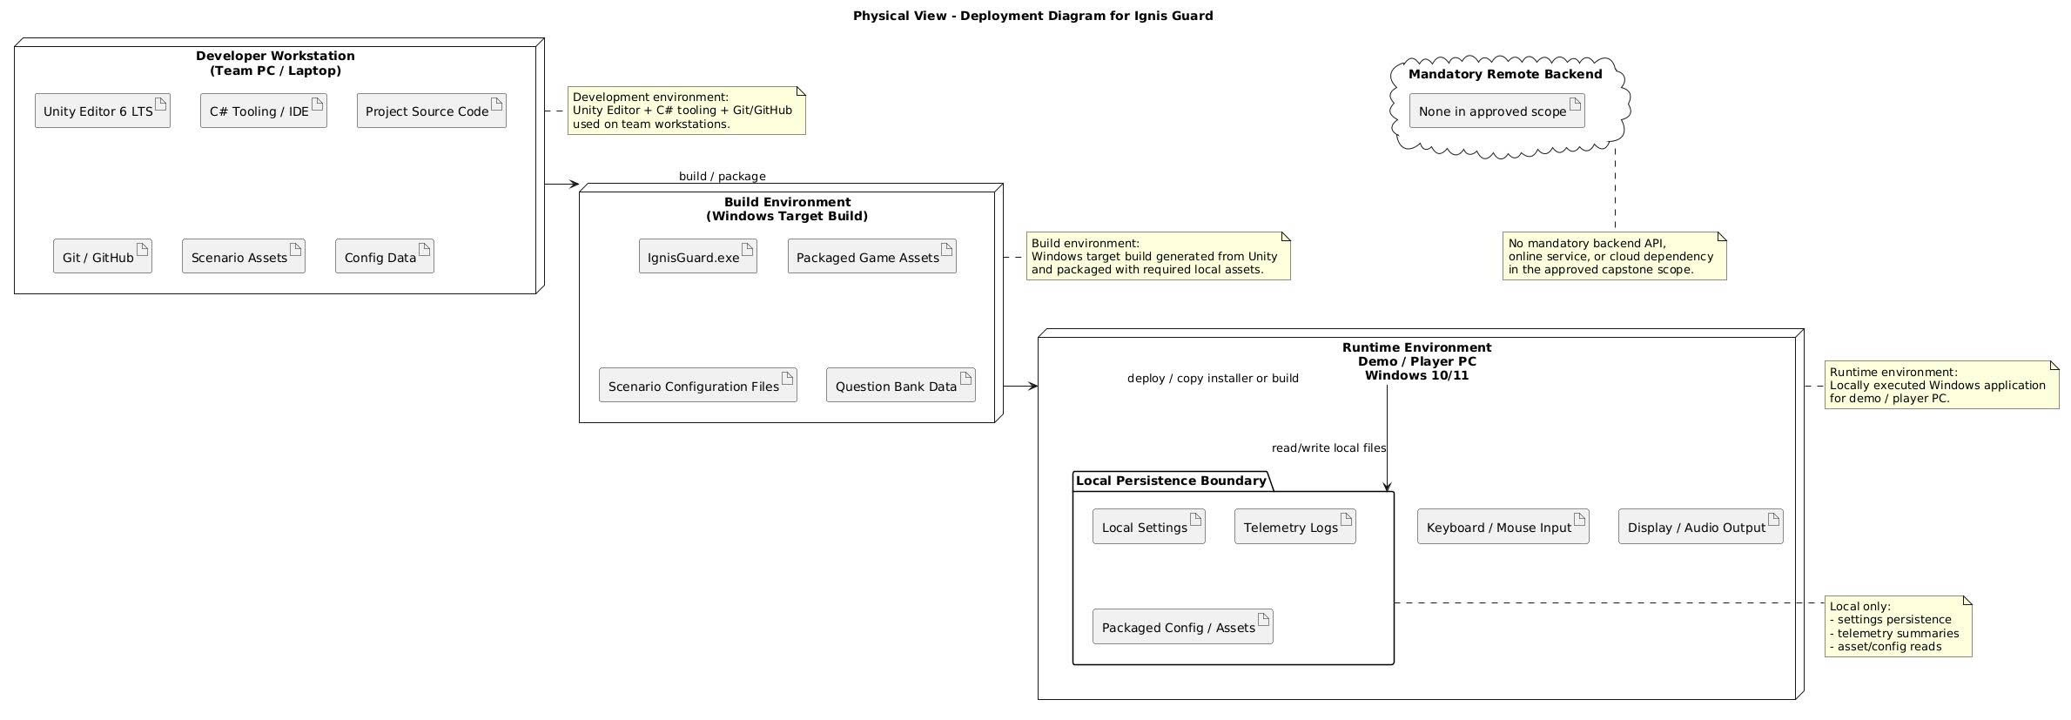
Figure 4.4 Physical / deployment view for local build creation and runtime execution

Table 4.3 Physical Environment Overview
Physical Element | Description
Development environment | Unity Editor + C# tooling + Git/GitHub used on the team workstations.
Build environment | Windows target build generated from Unity and packaged with all required local assets.
Runtime environment | Demo or player PC running Windows 10/11 with keyboard, mouse, display, and audio output.
Persistence boundary | Local only: settings, telemetry summaries, and asset/config reads.

Architecture Rationale
The selected architecture deliberately prioritizes clarity, determinism, and reusability over highly dynamic or research-grade simulation complexity. A state-based core makes the player-visible flow predictable and easier to validate. A modular domain layer keeps scoring, mission logic, bot commands, and call-to-scene mapping separable for debugging and iteration. A data-driven scenario approach gives the team room to support two scenarios within the capstone schedule without implementing separate custom engines for each scenario.
This approach also supports quality management. Non-functional drivers such as maintainability, stability, and testability are better served when content data can change while the central game flow remains stable. In a capstone context, this trade-off is more valuable than a heavier architecture that would increase complexity without proportionate academic benefit.

Component Design
This chapter describes the principal architectural components at a level sufficient to guide implementation, integration, and testing. Each subsection focuses on component responsibility, data inputs/outputs, and dependencies rather than low-level class declarations.

Main Menu and Scenario Selection
Table 5.1 Main Menu and Scenario Selection Module Description
Attribute | Description
Primary purpose | Provide the player entry point into the application and allow safe navigation to tutorial, settings, and scenario start.
Key responsibilities | • Display available scenarios and basic scenario summaries.  • Route player actions to Tutorial, Settings, or mission start paths.  • Validate that only approved scenarios are selectable in the current build.
Main inputs | • Player input from mouse / keyboard.  • Scenario availability metadata.  • Saved settings if present.
Main outputs | • Selected scenario identifier.  • Navigation event for the Game Flow Controller.  • Visible menu state.
Dependencies | • Game Flow Controller  • Scenario configuration registry  • Settings persistence
Design notes | This component should remain thin. It must not own mission logic or configuration rules beyond scenario presentation and user navigation.

Game Flow Controller
Table 5.2 Game Flow Controller Module Description
Attribute | Description
Primary purpose | Coordinate all major user-visible states and enforce legal transitions across the shared gameplay loop.
Key responsibilities | • Initialize startup sequence and enter the correct first state.  • Control transitions between Main Menu, Tutorial, Scenario Selection, Call Phase, Loadout Briefing, Mission, Pause, and Debrief.  • Prevent illegal or premature transitions.  • Reset or preserve session context as required by replay / exit actions.
Main inputs | • Navigation events.  • Scenario selection events.  • Call Phase completion events.  • Mission end events.
Main outputs | • Active application state.  • Transition commands.  • Session reset or continuation requests.
Dependencies | • Session Context / Event Broker  • UI layer  • Scene / Scenario Loader
Design notes | This module is the backbone of runtime stability. It should centralize state ownership rather than allow screen-level scripts to transition independently.

Call Phase Module
Table 5.3 Call Phase Module Description
Attribute | Description
Primary purpose | Implement the emergency-call questioning experience and capture the information that seeds the rest of the mission.
Key responsibilities | • Present the currently available questions.  • Track timing or turn limits.  • Store the player’s question history and caller responses.  • Update notepad / summary data during the call.  • Emit a finalized call-session payload when the phase ends.
Main inputs | • Question bank data.  • Scenario-specific caller data.  • User selections.  • Timer or turn configuration.
Main outputs | • CallSession record.  • Notepad entries.  • Phase completion signal.
Dependencies | • Question Bank  • UI/HUD Layer  • Session Context / Event Broker
Design notes | Because FR-04 and FR-05 drive much of the educational value, the Call Phase must remain deterministic, readable, and easy to instrument for testing.

Incident State Mapping Engine
Table 5.4 Incident State Mapping Engine Module Description
Attribute | Description
Primary purpose | Convert call-session results into a deterministic Incident State used by downstream systems.
Key responsibilities | • Evaluate the collected answers against rule tables or weighted mappings.  • Derive smoke density, fire intensity, spread rate, gas-hazard status, electric-hazard status, victim count, and victim location hints.  • Normalize the output so that later systems receive a stable configuration structure.
Main inputs | • CallSession data.  • Scenario-specific mapping rules.  • Optional timing / certainty modifiers.
Main outputs | • IncidentState object.  • Confidence / warning indicators where required.  • Mission configuration seeds.
Dependencies | • Call Phase Module  • Scenario rule data  • Session Context
Design notes | This component is one of the most architecture-critical modules because it establishes the project’s cause-and-effect learning loop. The same inputs must yield the same outputs.

Scenario Configuration and Scene Loader
Table 5.5 Scenario Configuration and Scene Loader Module Description
Attribute | Description
Primary purpose | Load the selected scenario and apply the Incident State to produce a configured mission scene.
Key responsibilities | • Read the selected scenario definition.  • Instantiate or activate the correct scene.  • Apply hazard toggles, smoke/fire levels, victim placement hints, and mission context.  • Prepare runtime systems and HUD dependencies before gameplay begins.
Main inputs | • Scenario identifier.  • ScenarioConfig data.  • IncidentState.  • Mission defaults.
Main outputs | • Configured scene and mission context.  • Spawn setup.  • Active objective seed.
Dependencies | • Game Flow Controller  • Incident State Engine  • Mission System  • Unity scene content
Design notes | This component is the main mechanism for supporting two scenarios through one architecture. It should prefer configuration over bespoke scene-control logic whenever practical.

On-site Gameplay Module
Table 5.6 On-Site Gameplay Module Description
Attribute | Description
Primary purpose | Handle the player’s first-person movement, interaction, tool use, and direct environmental action during mission runtime.
Key responsibilities | • Support movement, camera look, interaction prompts, and basic tool usage.  • Apply tool effects to hazards, interactables, or mission-relevant objects.  • Produce interaction events consumed by mission tracking, scoring, and hazard handling.
Main inputs | • Player movement input.  • Interaction prompts and target states.  • Mission and environment context.
Main outputs | • Player actions.  • Environment state updates.  • Interaction events for downstream systems.
Dependencies | • Unity Input System  • Mission System  • HUD  • Tool prefabs / environmental objects
Design notes | The on-site gameplay logic should remain focused on player action execution. Objective completion rules and score decisions belong to other components. The full ToolWheel equipment set is implemented here: ThermalCamera (reveal victims through smoke), OxygenMask (protect player from smoke), VictimStabilizationKit (stabilize victim before transport), RescueCushionPlaceable (catch falling victims), StandardLadderPlaceable and RopeLadderPlaceable (climbable placement), PortableWorkLightPlaceable (illuminate dark areas), fire extinguisher (suppress fire clusters), and breakable obstacles (MeshShatter / Breakable). Tool selection is managed via the ToolWheel UI component.

Mission and Objective System
Table 5.7 Mission and Objective System Module Description
Attribute | Description
Primary purpose | Track main and side objectives in parallel using a flat, event-driven architecture, and manage mission success/failure logic.
Key responsibilities | • Represent the mission tree and current objective state.  • Track each objective independently via event-driven triggers; objectives run in parallel rather than hard prerequisite gates.  • Update objective progress based on gameplay events.  • Emit mission completion, fail, or timeout conditions.
Main inputs | • MissionConfig.  • Interaction events.  • Hazard or rescue status changes.  • Timer state if used.
Main outputs | • Updated objective status.  • Current mission phase.  • Mission-end signals.
Dependencies | • Scenario Loader  • On-site Gameplay Module  • Scoring Module  • HUD
Design notes | This component uses a Flat Objective Architecture: objectives (e.g., ExtinguishFires, RescueTargets) are tracked in parallel as a flat list. Players can execute tasks in any order; the Scoring Module evaluates prioritization and SOP adherence in the Debrief phase. Avoid hard prerequisite gates that block objective completion.

Teammate Command / Bot Module
Table 5.8 Teammate Command / Bot Module Description
Attribute | Description
Primary purpose | Provide bounded command-based support behavior for bot teammates within the approved scope.
Key responsibilities | • Receive player-issued commands.  • Translate commands into bot state changes or AI tasks.  • Handle fallback when pathfinding or execution fails.  • Expose current bot status to the UI and mission systems.
Main inputs | • Command UI selections.  • Current bot state.  • Navigation context.  • Target or objective references.
Main outputs | • Bot action requests.  • Status feedback.  • Fallback or cancel signals.
Dependencies | • Unity NavMesh  • Command UI  • Mission System
Design notes | The architecture intentionally keeps this module narrow. Robustness is more important than expressive AI complexity in the current capstone scope.

Scoring and Evaluation Module
Table 5.9 Scoring and Evaluation Module Description
Attribute | Description
Primary purpose | Compute mission score, penalties, grade lock, and final rank from runtime outcome data.
Key responsibilities | • Collect objective completion, mission time, safety penalties, and rule-based score modifiers.  • Apply grade-lock logic for severe safety violations.  • Produce a final rank and a structured score breakdown.
Main inputs | • Mission outcome data.  • Penalty events.  • Scoring thresholds and rank thresholds.
Main outputs | • ScoreRecord.  • Final rank.  • Breakdown for debrief rendering.
Dependencies | • Mission System  • Hazard / violation events  • Debrief Module
Design notes | This component should remain data-driven where possible so that balancing can happen through configurable thresholds rather than logic rewrites.

Debrief Module
Table 5.10 Debrief Module Description
Attribute | Description
Primary purpose | Generate and present the reflective learning summary after a mission ends.
Key responsibilities | • Create a cause-and-effect explanation tied to call choices and mission events.  • Display score breakdown, penalties, final rank, and replay / exit options.  • Support debrief generation even when the mission ends in failure or timeout.
Main inputs | • ScoreRecord.  • MissionState summary.  • IncidentState summary.  • Optional telemetry summary.
Main outputs | • DebriefRecord.  • UI presentation model.  • Replay / exit actions.
Dependencies | • Scoring Module  • Session Context  • UI Layer  • Game Flow Controller
Design notes | The debrief is central to the educational objective of the product. Its architecture should preserve traceability from earlier decisions to later outcomes.

UI / HUD Module
Table 5.11 UI / HUD Module Description
Attribute | Description
Primary purpose | Render the player-facing interface across menu, call, mission, pause, settings, and debrief states.
Key responsibilities | • Display scenario selection, call controls, notepad, objective tracker, prompts, command UI, and end-of-mission feedback.  • Maintain readability in smoke / fire-heavy scenes.  • Present only the information relevant to the current state or context.
Main inputs | • View models from the active application / gameplay components.  • Player input focus changes.  • Settings values.
Main outputs | • Player commands.  • Visible feedback.  • State-aware interface rendering.
Dependencies | • Game Flow Controller  • Mission System  • Scoring and Debrief  • Settings
Design notes | UI should be state-aware rather than directly owning data transformations. This keeps the interface responsive while preserving clean architecture boundaries.

Local Logging / Telemetry Module
Table 5.12 Local Logging / Telemetry Module Description
Attribute | Description
Primary purpose | Persist playtest-relevant runtime data without disrupting the user-facing flow.
Key responsibilities | • Record build version, scenario, mission time, objective completion, safety penalties, and final rank.  • Write logs to an accessible local location for Dev / QA review.  • Fail safely if logging is unavailable or partially incomplete.
Main inputs | • Mission-end data.  • Build / scenario metadata.  • Optional debug events.
Main outputs | • TelemetryEvent or summary file.  • Error-safe status response.
Dependencies | • Session Context  • Scoring Module  • File I/O abstraction
Design notes | The module must never compromise gameplay stability. Logging is valuable, but the current capstone scope does not justify heavy asynchronous analytics infrastructure.

Data Design

Data Design Overview
Ignis Guard is not a data-intensive enterprise system, but its educational architecture depends strongly on well-structured runtime data. The main data design principle is to separate stable content/configuration data from per-session runtime state. This separation allows the team to author or tune scenarios without rewriting the core game flow and also enables cleaner traceability from inputs to outputs.
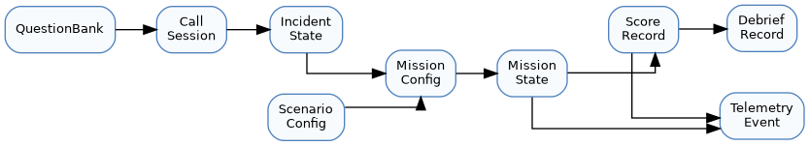
Figure 6.1 Simplified data relationships across the core architecture

Core Data Entities
Table 6.1 Core Data Entities and Their Purposes
Entity | Key Fields / Attributes | Purpose
Question | Unique question identifier, text, category, optional weight / tag | Defines one selectable call question in the Call Phase.
CallSession | Selected scenario, asked questions, caller responses, timer / turn result | Captures the completed emergency-call interaction.
IncidentState | Smoke density, fire intensity, spread rate, gas-hazard status, electric-hazard status, victim count, victim location hints | Normalized parameter set inferred from CallSession.
ScenarioConfig | Scenario id, scene reference, mission defaults, hazard rules, objective templates | Stores scenario-specific configuration data.
MissionConfig | Resolved runtime configuration for one mission session | Combines ScenarioConfig and IncidentState into one launchable configuration.
MissionState | Active objectives, statuses, current phase, mission-end flags | Tracks live mission progress.
ScoreRecord | Objective result, time, penalties, grade lock, final rank | Stores the formal mission evaluation result.
DebriefRecord | Timeline items, explanatory text, score presentation model | Stores the final reflective feedback for the player.
TelemetryEvent / Summary | Scenario, build version, result metrics, timestamps | Supports local playtest analysis and tuning.

Question and Answer Data Model
The Call Phase relies on a structured question bank. Each question should include a unique identifier, display text, category, and a mapping hook that connects the answer to one or more Incident State rule entries. The data model should make it possible to reuse question patterns across scenarios while still allowing scenario-specific answers or relevance weighting.
Table 6.2 Question Data Fields and Their Design Roles
Field | Design Role
Question ID | Stable lookup key used by rules and telemetry.
Display Text | Player-facing wording shown in the Call Phase UI.
Category / Tag | Helps group questions (hazard, victims, spread, access, etc.).
Scenario Applicability | Determines whether the question is globally valid or only meaningful in selected scenarios.
Mapping Hook | Links answer outcomes to Incident State logic.

Incident State and Scenario Configuration Data
Incident State data must be normalized before scene configuration occurs. The architecture should avoid ad hoc boolean flags scattered across unrelated scripts. Instead, mission-relevant variables should be grouped into a dedicated IncidentState structure and consumed by the Scenario Loader as a well-defined input.
Table 6.3 Runtime Configuration Structures Overview
Structure | Description
IncidentState | Contains calculated runtime parameters derived from call information.
ScenarioConfig | Contains author-created scenario defaults and scene references.
MissionConfig | Represents one resolved mission session after combining the first two structures.

Mission and Objective Data Model
Mission data should represent objectives as explicit nodes or records with identifiers, status, prerequisite conditions, and scoring relevance. This is important for both mission correctness and debrief explanation. Objectives are tracked in parallel using event-driven triggers; the system distinguishes main from side objectives and grades prioritization in the Debrief phase.
Table 6.4 Mission Objective Fields and Meanings
Field | Meaning
Mission Node ID | Unique identifier used for prerequisite and event mapping.
Objective Type | Main objective, side objective, rescue step, hazard-control step, etc.
Completion Conditions | Event-driven conditions (e.g., area reached, objective interacted, victim rescued) that trigger objective completion independently.
Status | Not started, active, blocked, completed, failed.
Score Weight / Penalty Link | Connects objective outcome to scoring behavior.

Scoring, Debrief, and Telemetry Data
Score, debrief, and telemetry data are related but should not be collapsed into a single unstructured log. ScoreRecord should represent the formal mission result. DebriefRecord should represent the player-facing reflective explanation. Telemetry should represent a storage-friendly summary for analysis and tuning.
Table 6.5 Result and Reporting Data Structures
Structure | Role
ScoreRecord | Stores mission time, objective result, penalties, grade lock, and final rank.
DebriefRecord | Stores ordered explanatory items and UI-ready presentation content.
Telemetry summary | Stores scenario, build version, timestamps, completion metrics, and final result data for QA.

Data Storage and Configuration Format
- Scenario and mission content should be stored in author-friendly Unity data assets (such as ScriptableObjects) wherever practical.
- Question banks and small configuration tables may also be represented as JSON or serialized data if this improves portability or iteration speed.
- Local settings and telemetry summaries should use lightweight local file formats that can be read by the team without special infrastructure.

Data Validation and Integrity Rules
- Every question, scenario, objective, and score rule should have a stable identifier.
- Scenario configuration must not reference missing scene assets or undefined objective templates.
- The Incident State engine must always produce a valid normalized output, even when call data is incomplete.
- Telemetry writing failures must not break the player-facing flow or corrupt mission result presentation.

Deployment Design

Target Platform and Environment
The approved deployment target is PC Windows (Windows 10/11). The build is expected to run locally in a classroom, lab, or demonstration environment without requiring online services. The runtime architecture therefore favors local packaging, predictable hardware assumptions, and straightforward launch behavior.

Software Deployment Structure
Table 7.1 Software Deployment Structure Overview
Deployment Element | Description
Application package | Windows executable and all required local game data / asset bundles.
Configuration package | Scenario configuration assets, question data, and gameplay thresholds.
Optional persistence | Local settings and telemetry output stored in accessible local folders.

Build and Packaging Strategy
The team should maintain at least three practical build categories: development build, test / evaluation build, and release / defense build. The build output should include a clear version label, selected scenario support, and any necessary readme or launch instructions. Packaging should remain simple and reproducible so that the same executable can be demonstrated on the target machine with minimal setup.

Runtime Dependencies
Table 7.2 Runtime Dependencies and Deployment Implications
Dependency | Deployment Implication
Unity runtime dependencies | Included through the build and packaged with the application as required by Unity.
Input dependency | Keyboard and mouse availability.
Rendering / hardware dependency | A GPU and CPU combination capable of running the approved scenarios at acceptable frame rate.
Local storage dependency | Permission to read packaged data and write basic local logs / settings.

Configuration and Versioning Considerations
Scenario content, scoring thresholds, and telemetry format should be version-aware so that test results can be interpreted correctly. The build should expose or record a build version identifier, because FR-17 requires local telemetry to remain meaningful for playtest / tuning. When content changes occur, the architecture should support replacing or tuning configuration data without requiring deep structural changes to the rest of the build.

Operational Limitations
- No networked multiplayer synchronization is supported in the current architecture.
- No backend analytics service is required or assumed.
- No mobile or VR-specific deployment pipeline is considered in the approved scope.
- The deployment view is intentionally minimal because the product is delivered as a locally run serious game for capstone defense and evaluation.

Design Patterns and Frameworks

Architectural Patterns Used
Table 8.1 Architectural Patterns Used in Ignis Guard
Pattern / Style | Application in Ignis Guard
State-based control | The Game Flow Controller acts as the central runtime state owner for major application phases.
Data-driven scenario configuration | Scenario differences are modeled through data assets and rule tables rather than through duplicate game-flow code.
Layered logical separation | Presentation, control, domain, and data responsibilities are separated to reduce coupling.

Design Patterns Used
Table 8.2 Design Patterns Used and Their Rationale
Pattern | Rationale
State Pattern | Applied to the main runtime flow (menu, call, mission, pause, debrief) so transitions stay explicit.
Command Pattern | Fits the teammate command system, where UI-issued commands are converted into bounded bot actions.
Observer / Event-based communication | Supports decoupled notifications between gameplay events, mission tracking, scoring, and HUD updates.
Strategy / Rule-table style mapping | Useful for Incident State calculation, score weighting, and scenario-specific rule differences.
Factory / Builder-like composition | Useful in the Scenario Loader when building a MissionConfig from ScenarioConfig + IncidentState.

Frameworks / Libraries / Engine Support
Table 8.3 Frameworks / Libraries / Engine Support and Their Roles
Framework / Technology | Role in the Architecture
Unity Engine | Core runtime, scene management, and asset pipeline.
Universal Render Pipeline (URP) | Real-time rendering with manageable performance cost.
Unity Input System | Centralized input handling for keyboard / mouse.
Unity NavMesh | Basic pathfinding support for teammate bot behavior.
C# language and standard Unity component model | Primary code structure for scripts and gameplay logic.

Rationale for Pattern and Technology Selection
The selected patterns are deliberately pragmatic. The project needs enough structure to remain stable and maintainable, but it also needs to stay feasible for a small capstone team. State-based control improves stability. Event-driven communication reduces unnecessary coupling between gameplay modules. Rule-based / strategy-like configuration supports deterministic educational logic. Unity-native frameworks reduce integration cost and keep the technology stack aligned with the team’s existing plan and schedule.
The architecture intentionally avoids heavier patterns such as distributed services, asynchronous backend messaging, or AI systems that exceed the educational and capstone objectives. The chosen design is therefore not minimalistic by accident; it is a focused response to scope, timeline, and quality drivers.

Traceability Matrix

Functional Requirement to Architecture Mapping
Table 9.1 Functional Requirement to Architecture Mapping
Req. ID | Requirement Theme | Architectural Element(s) | Coverage Note
FR-03 | Two selectable scenarios | Main Menu / Scenario Selection; Scenario Loader; ScenarioConfig | Supports Urban High-rise and Suburban House using one shared architecture.
FR-04 | Call question list with limit | Call Phase Module; Question Bank | Bounded questioning structure with timer / turn support.
FR-05 | Notepad and summary update | Call Phase Module; UI/HUD | Call interaction must continuously update visible summary data.
FR-06 | Incident State inference | Incident State Engine; Session Context | Deterministic mapping from call inputs to scene parameters.
FR-07 | Loadout summary | Incident State Engine; Loadout UI; Session Context | Provides pre-mission briefing derived from the inferred state.
FR-08 | On-site entry with HUD and mission tree | Game Flow Controller; Scenario Loader; Mission System; UI/HUD | Connects pre-mission data to runtime mission setup.
FR-10 | Mission tree generation and updates | Mission and Objective System | Supports main and side objectives in parallel (Flat Objective Architecture); event-driven tracking.
FR-11 | Bot commands | Teammate Command Module; UI/HUD; NavMesh support | Bounded command execution and fallback behavior.
FR-13 / FR-18 | Debrief, score, penalties, grade lock | Scoring Module; Debrief Module | Captures educational feedback and safety consequences.
FR-17 | Local telemetry persistence | Local Logging / Telemetry Module | Stores playtest metrics without disrupting runtime flow.

Non-Functional Requirement to Architecture Mapping
Table 9.2 Non-Functional Requirement to Architecture Mapping
Req. ID | Quality Driver | Architectural Response
NFR-01 | Performance | URP use, bounded hazard activation, modular scene configuration, lightweight rule evaluation
NFR-03 | Stability | Explicit Game Flow Controller, defensive scene loading, bounded module responsibilities
NFR-04 | Bot robustness | Fallback handling in the command/bot module and limited command scope
NFR-05 | Maintainability | Data-driven scenario config, isolated scoring thresholds, modular components
NFR-06 | Learnability | State-aware UI, tutorial / main loop clarity, readable HUD and debrief
NFR-07 | Compatibility | Windows-only local deployment and simple runtime dependency profile

Component-to-Requirement Traceability Summary
Table 9.3 Component-to-Requirement Coverage Matrix
Component | Primary Requirement Coverage
Game Flow Controller | FR-08, FR-14, FR-15, NFR-03
Call Phase Module | FR-04, FR-05, NFR-06
Incident State Engine | FR-06, FR-07, NFR-05
Scenario Loader | FR-03, FR-08, FR-12, NFR-01
Mission System | FR-01, FR-10, FR-12, FR-18
Bot Module | FR-11, NFR-04
Scoring + Debrief | FR-13, FR-18
Telemetry Module | FR-17, NFR-03
Fire Simulation System | FR-19, FR-12, NFR-01
Seed System (IncidentSeedUtility / IncidentWorldSetupPayload) | FR-20, FR-06, FR-07, NFR-05

